[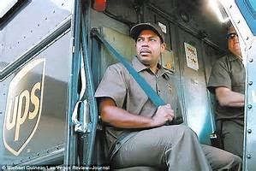](http://www.bing.com/images/search?view=detailV2&ccid=Dk8QvKqp&id=CE872BE75DD5DFAD37C0EF5B82CE03DD290A939A&q=ups+black+delivery+guy&simid=608025030989644162&selectedIndex=5)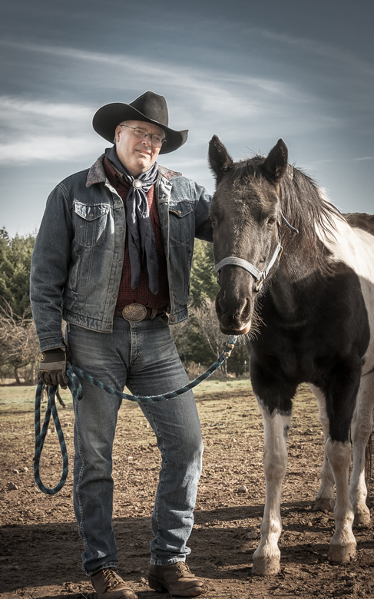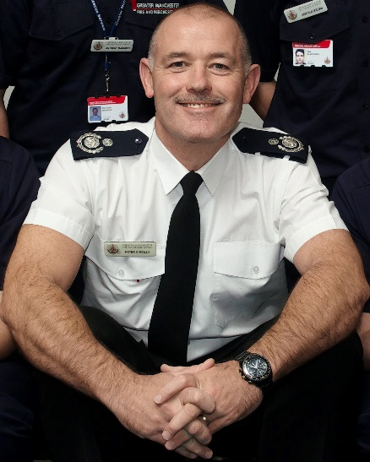

Eugene, 32

Eugene is working as the Manager of a regional distribution center for UPS. Like many UPS managers, Eugene started working on the dock just after high school. He also drove a route for several years and has advanced to a junior management position. He attended night school to finish his undergraduate degree. He knows that he will need an MBA to advance further at UPS. The company will pay for his degree; however, he will have to study part-time at a university close to his work. His wife is expecting their first baby and taking two years off for school is just not an option.

Tammi, 27

Tammi is currently working as a Software Engineer for Intel. She grew up in Beaverton, OR, and completed her undergraduate degree in Computer Science at Portland State. She went to work at Intel right out of college. She really enjoys her technical career; however, she also wants to advance into management. She is considering a transition to marketing – the money is better and she will get to travel for work. Plus, she has a good friend in marketing who really seems to enjoy it. Tammi is an active tri-athlete and is still looking for the right guy to start a family with.

Luke, 34

Luke is working as the Station Manager at a local Fire Department. He comes from a large Irish family and his Dad and Grandfather were both in the Fire Department too. He relishes work on the front-line fighting fires; however, his wife worries about his safety and the future of their daughters – what would they do if something happened to Luke? She has been pushing Luke to move into more of a management role. Luke has resisted so far, but believes this may finally be the time. He will need to get his MBA in order to show that he has the skills to advance.

Yvonne, 32

Yvonne is the daughter of French immigrants. She has always had a deep love for science and for the environment. She was the captain of the high school chemistry team and a top graduate. She completed her undergraduate degree in bio-chemistry degree at OSU at 22. Since that time, she has been working for the State of Oregon, dealing with land conservation issues. She lives in eastern Oregon with her husband, twin boys, and an Irish setter. She knows that an MBA will be required to move out of her technical role into a management position with the state.

Calvin “Cal”, 38

Cal was born and raised in La Grande, OR. He is a fifth generation cattle rancher working a piece of the family farm – he and his wife took over the ranch when his Father passed away ten years ago. Cal got his undergraduate degree in History at EOU. Since that time, he has been working hard trying to make the family ranch thrive. Cal knows everything there is to know about ranching; but, times have changed. The world has gone global, competition is stiff, and he knows he will have to get additional skills if he wants to be able to hand the ranch over to his two sons someday.

Maggie, 28

Maggie is a third generation Mexican-American. She is married and has a 6 year old daughter who lives with her Dad while she is on active duty. She joined the military just out of high school and finished her bachelor’s degree online. Maggie really enjoys her career in the military but misses spending quality time with her family. She will need to decide next year weather to pursue her military career further or leave to work in the family business. Either way, she knows that she will need additional management skills (and credentials) to take the next step.